FMX Mobile Application Development
Lab Exercise 02.01: Starting up with InterBase

Open the InterBase Server Manager (choose Start > Programs > Embarcadero InterBase 2017 > InterBase Server Manager [instance = gds_db]).
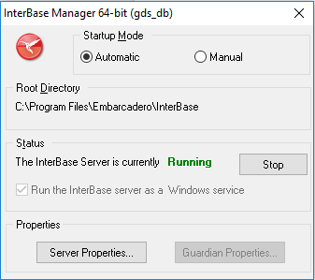
Use Start to start the server. The status text changes to Running.
To see additional information about the InterBase Server, select Server Properties.
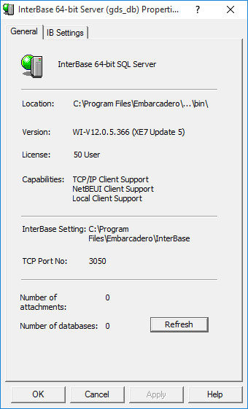
To see additional information about the InterBase Guardian, select Guardian Properties.

To log on to the local InterBase server:
- Open IBConsole.
- Use Server > Login.
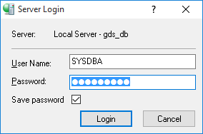
- Login using the default credentials (user:SYSDBA, password:masterkey).
- You can see the name of the logged-in user in the status bar of IBConsole

